# Single input with correct market select

* 1. Single input for Chinese Mainland(CN)

Case No. 1.1

Input:

Stock id: **sh600680**

Market: **Chinese Mainland(CN)**

Output:

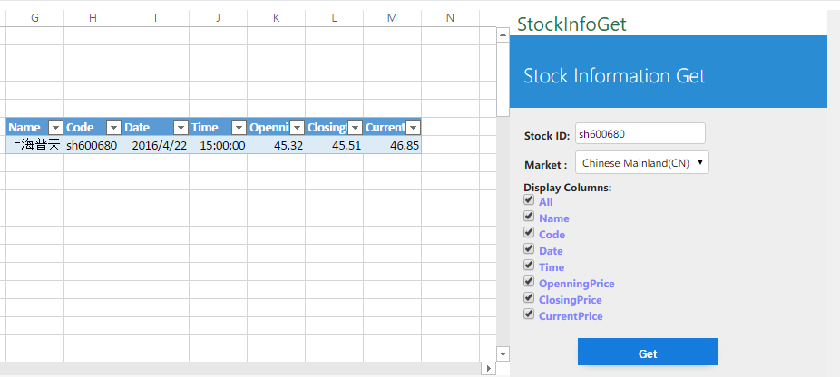

Result: PASS

* 1. Single input for Hong Kong(HK)

Case No. 1.2

Input:

Stock id: **00168**

Market: **Hong Kong(HK)**

Output:

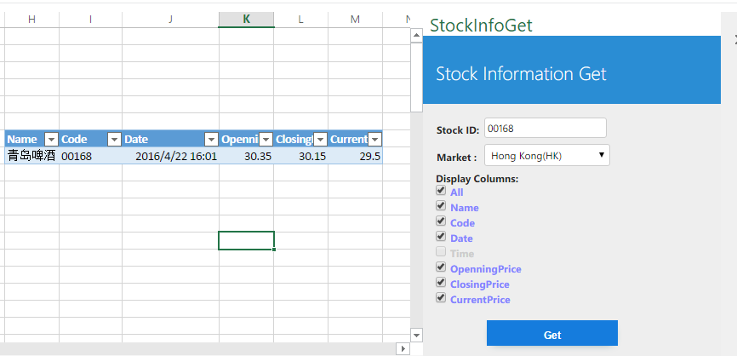

Result: PASS

* 1. Single input for United States(US)

Case No. 1.3

Input:

Stock id: **MSFT**

Market: **United States(US)**

Output:

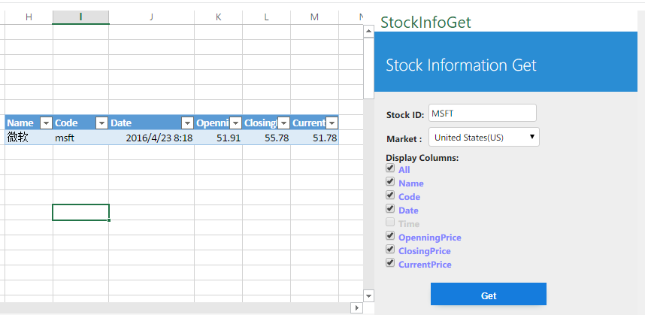

Result: PASS

# Multiple input with correct market select

* 1. Multiple input for Chinese Mainland(CN)

Case No. 2.1

Input:

Stock id: **sh600680,sz002230,sh601988**

Market: **Chinese Mainland(CN)**

Output:

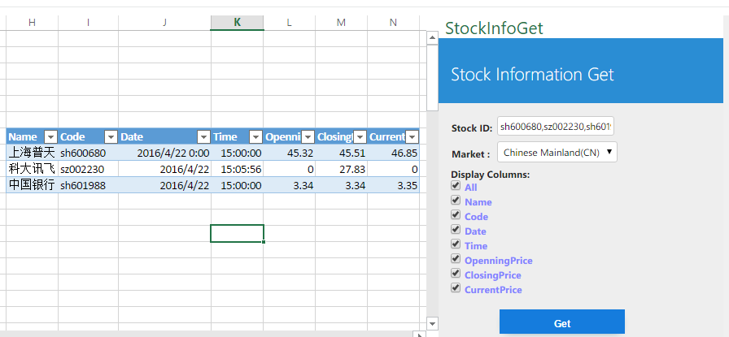

Result: PASS

* 1. Multiple input for Hong Kong(HK)

Case No. 2.2

Input:

Stock id: **00168,00941,00700**

Market: **Hong Kong(HK)**

Output:

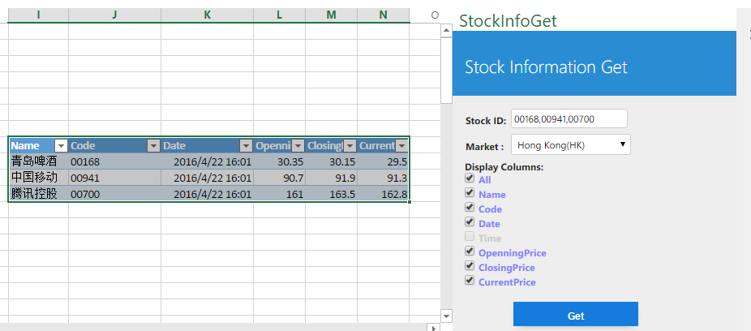

Result: PASS

* 1. Multiple input for United States(US)

Case No. 2.3

Input:

Stock id: **MSFT,C,GOOG**

Market: **United States(US)**

Output:

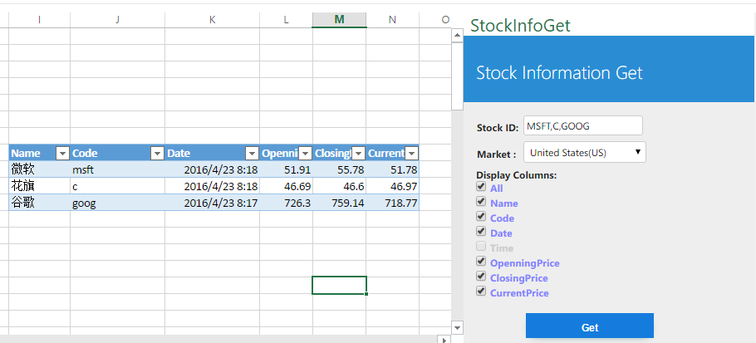

Result: PASS

# Empty input for different market

* 1. Empty input for Chinese Mainland(CN)

Case No. 3.1

Input:

Stock id: ***null***

Market: **Chinese Mainland(CN)**

Output:

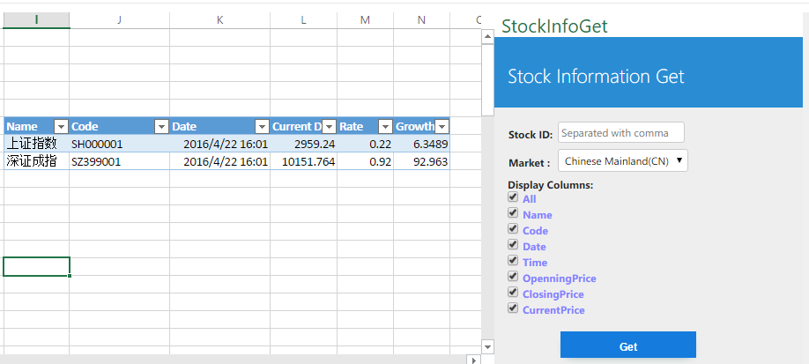

Result: PASS

* 1. Empty input for Hong Kong(HK)

Case No. 3.2

Input:

Stock id: ***null***

Market: **Hong Kong(HK)**

Output:

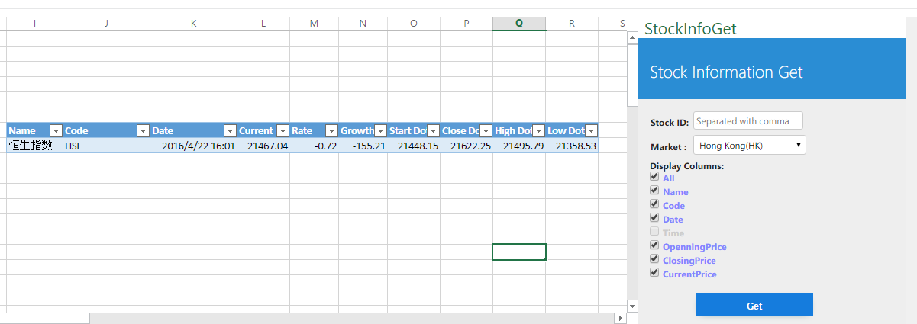

Result: PASS

* 1. Empty input for United States(US)

Case No. 3.3

Input:

Stock id: ***null***

Market: **United States(US)**

Output:

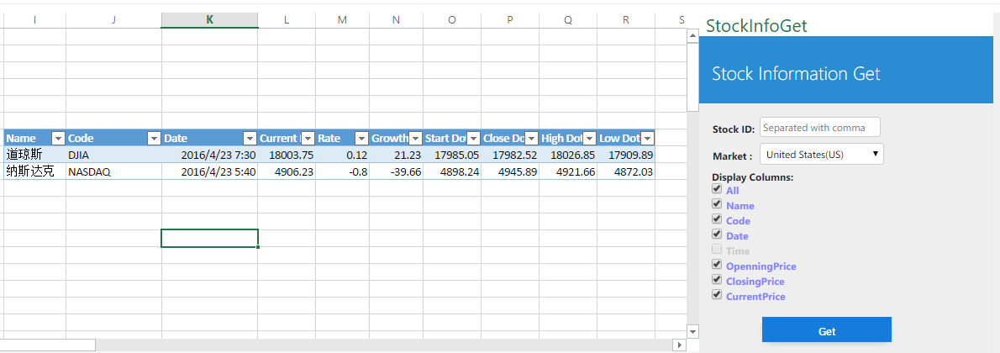

Result: PASS

# Upper and lower testing

* 1. Upper and lower testing for Chinese Mainland(CN)

Case No. 4.1

Input:

Stock id: **SH600680,sZ002230,sH601988**

Market: **Chinese Mainland(CN)**

Output:

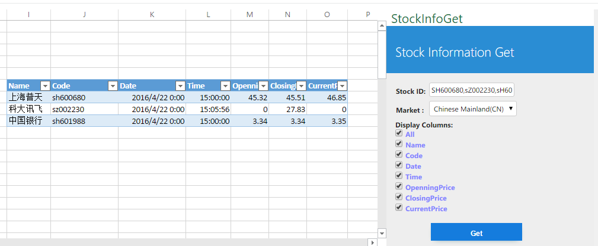

Result: PASS

* 1. Upper and lower testing for United States(US)

Case No. 4.2

Input:

Stock id: **MsfT,C,Goog,yhoo**

Market: **United States(US)**

Output:

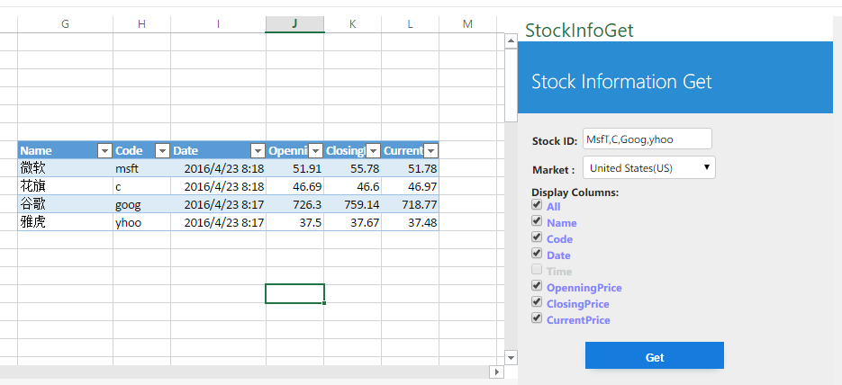

Result: PASS

# Column choose testing for all market

* 1. Column choose testing for Chinese Mainland(CN)

Case No. 5.1

Input:

Stock id: **sh600680,sz002230,sh601988**

Column: **Name/Date/Time/ClosePrice**

Market: **Chinese Mainland(CN)**

Output:

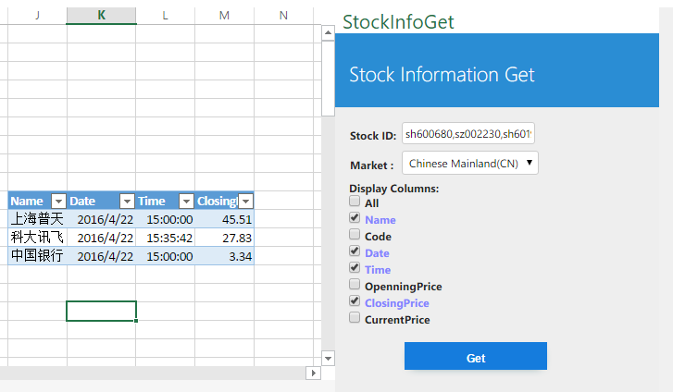

Result: PASS

* 1. Column choose testing for Hong Kong(HK)

Case No. 5.2

Input:

Stock id: **00168,00941,00700**

Column: **Name/Code/OpenningPrice/ClosePrice**

Market: **Hong Kong(HK)**

Output:

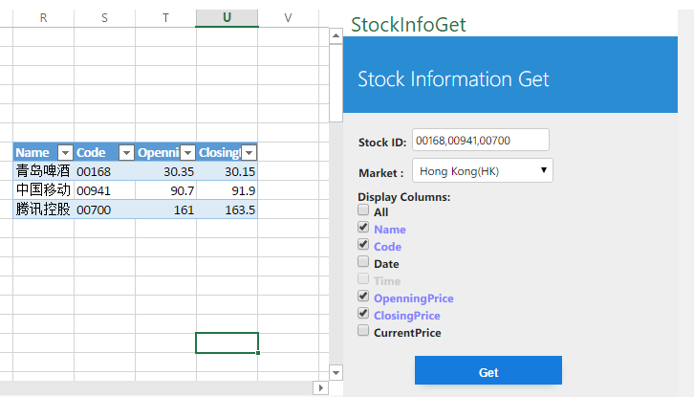

Result: PASS

* 1. Column choose testing for United States(US)

Case No. 5.3

Input:

Stock id: **MSFT,C,GOOG**

Column: **Code/Date/OpenningPrice/CurrentPrice**

Market: **United States(US)**

Output:

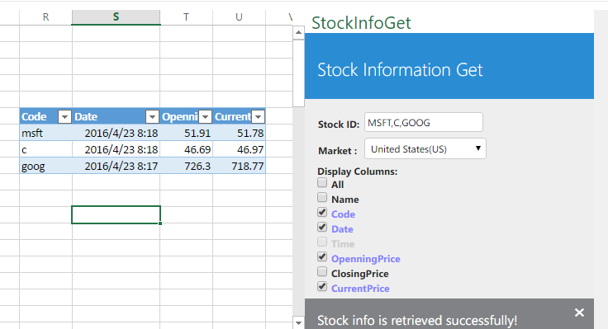

Result: PASS